Kyle Cole  
ITS362 Final Project  
Terebigemu.net SQL Documentation

**Tables & Stored Procedures for Terebigemu.net**

This document serves as an a proof of concept for the SQL tables and stored procedures used in this project. There is another document that has the HTML, PHP, and JavaScript documentation.

**Nintendo Table   
  
Table Structure**  
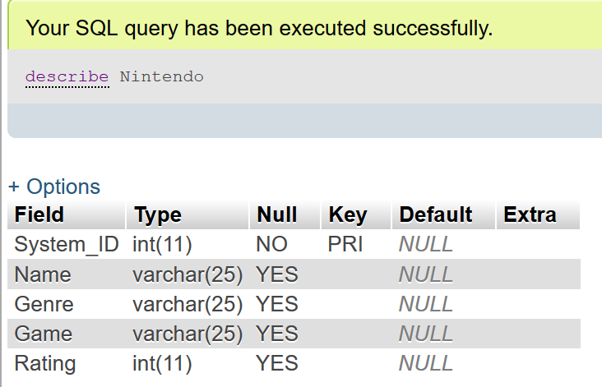  
  
**Insert_Nintendo Stored Procedure**

DELIMITER $$

CREATE DEFINER=`kyle`@`localhost` PROCEDURE `Insert_Nintendo`(IN `SYSTEM_ID` INT(11), IN `NAME` VARCHAR(25), IN `GENRE` VARCHAR(25), IN `GAME` VARCHAR(25), IN `RATING` INT(11))

NO SQL

INSERT INTO `Nintendo` (`System_ID`, `Name`, `Genre`,`Game`,`Rating`)

VALUES(SYSTEM_ID, NAME, GENRE, GAME, RATING)$$

DELIMITER ;  
  
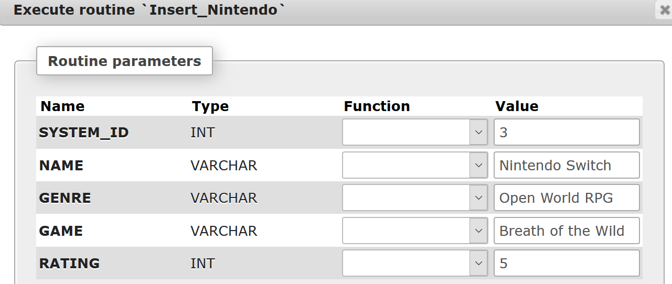  
  
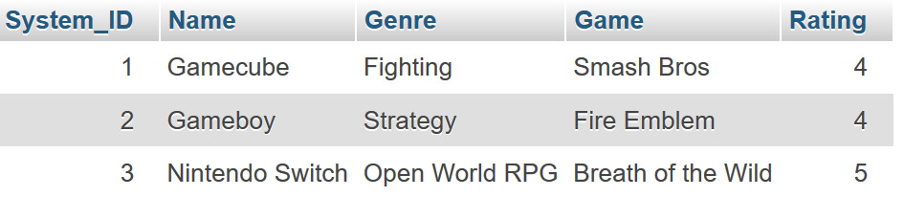  
Result of executing Insert_Nintendo in phpmyadmin

**Update_Nintendo Stored Procedure**DELIMITER $$

CREATE DEFINER=`kyle`@`localhost` PROCEDURE `Update_Nintendo`(IN `SYSTEM_ID` INT(11), IN `NAME` VARCHAR(25), IN `GENRE` VARCHAR(25), IN `GAME` VARCHAR(25), IN `RATING` INT(11))

NO SQL

UPDATE Nintendo

SET Name = NAME,

Genre = GENRE,

Game = GAME,

Rating = RATING

WHERE `Nintendo`.`System_ID` = SYSTEM_ID$$

DELIMITER ;  
  
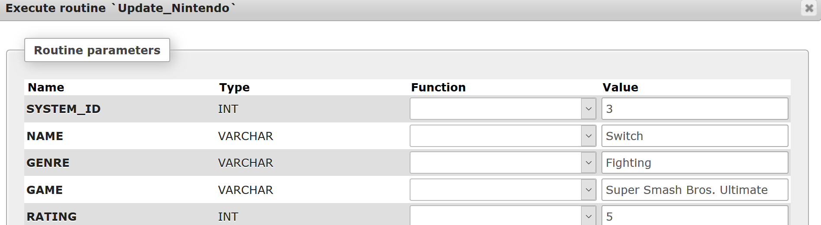  
  
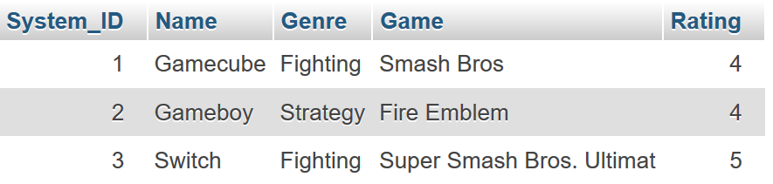  
Result of executing Update_Nintendo in phpmyadmin  
  
Should be noted: the table only support a total of 25 characters for any given character entry. I should have allowed more than 25 characters, but I didn’t think to. Most videogames I play have titles that are well under that many characters.  
  
**Delete_Nintendo Stored Procedure**DELIMITER $$

CREATE DEFINER=`kyle`@`localhost` PROCEDURE `Delete_Nintendo`(IN `SYSTEM_ID` INT(11))

NO SQL

DELETE FROM `Nintendo` WHERE `Nintendo`.`System_ID` = SYSTEM_ID$$

DELIMITER ;  
  
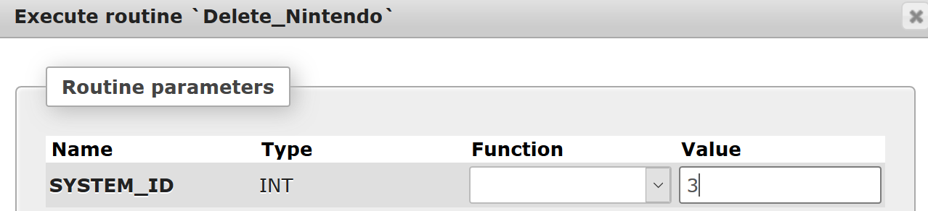

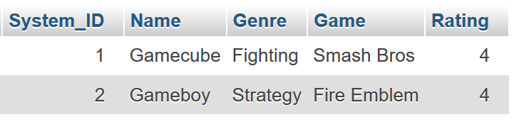  
Result of executing Delete_Nintendo in phpmyadmin

**Sony Table**  
**Table Structure**  
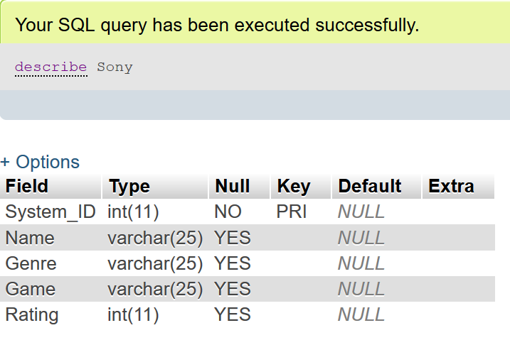  
  
**Insert_Sony Stored Procedure**DELIMITER $$

CREATE DEFINER=`kyle`@`localhost` PROCEDURE `Insert_Sony`(IN `SYSTEM_ID` INT(11), IN `NAME` VARCHAR(25), IN `GENRE` VARCHAR(25), IN `GAME` VARCHAR(25), IN `RATING` INT(11))

NO SQL

INSERT INTO `Sony` (`System_ID`, `Name`, `Genre`,`Game`,`Rating`)

VALUES(SYSTEM_ID, NAME, GENRE, GAME, RATING)$$

DELIMITER ;  
  
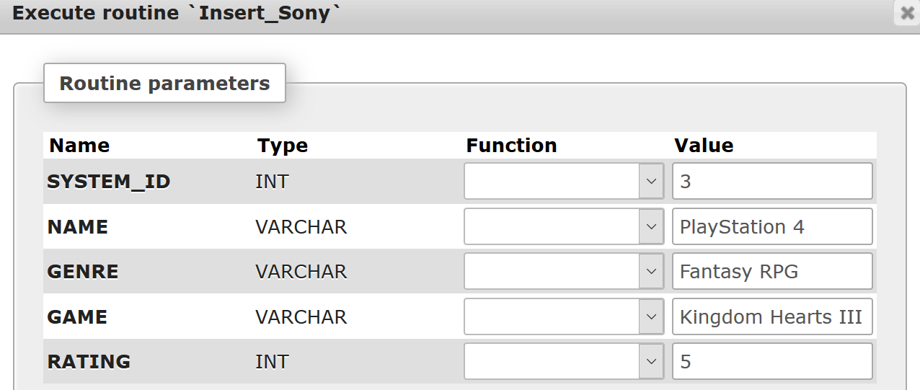  
  
  
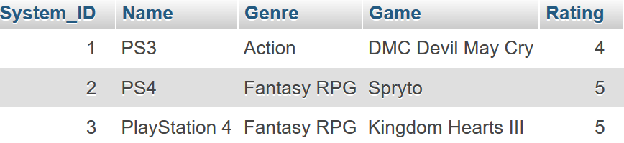  
Result of executing Insert_Sony in phpymyadmin  
  
**Update_Sony Stored Procedure**DELIMITER $$

CREATE DEFINER=`kyle`@`localhost` PROCEDURE `Update_Sony`(IN `SYSTEM_ID` INT(11), IN `NAME` VARCHAR(25), IN `GENRE` VARCHAR(25), IN `GAME` VARCHAR(25), IN `RATING` INT(11))

NO SQL

UPDATE Sony

SET Name = NAME,

Genre = GENRE,

Game = GAME,

Rating = RATING

WHERE `Sony`.`System_ID`= SYSTEM_ID$$

DELIMITER ;  
  
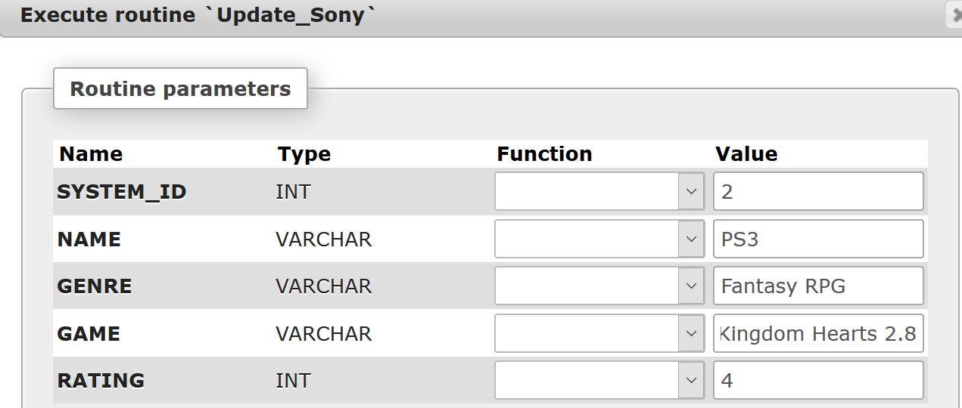  
  
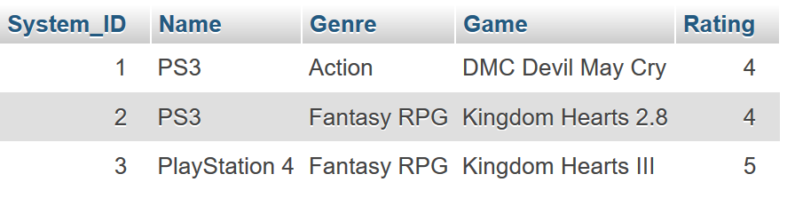  
Result of executing Update_Sony in phpymyadmin   
  
**Delete_Sony Stored Procedure**DELIMITER $$

CREATE DEFINER=`kyle`@`localhost` PROCEDURE `Delete_Sony`(IN `SYSTEM_ID` INT(11))

NO SQL

DELETE FROM `Sony` WHERE `Sony`.`System_ID` = SYSTEM_ID$$

DELIMITER ;  
  
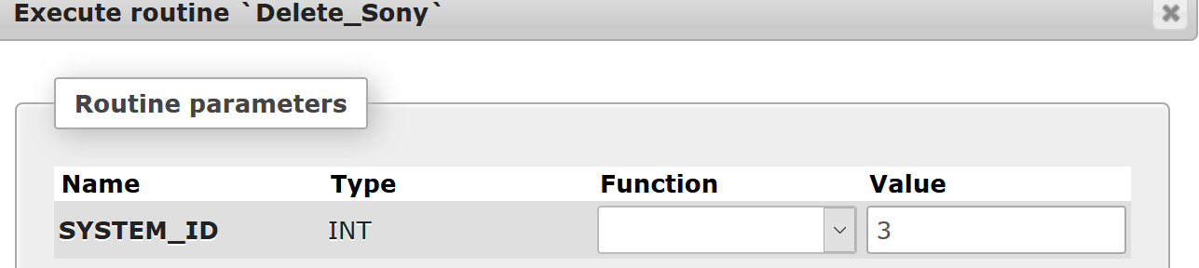  
  
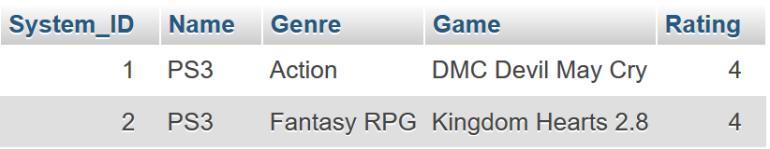  
Result of executing Delete_Sony in phpmyadmin

**Microsoft Table   
  
Table Structure**  
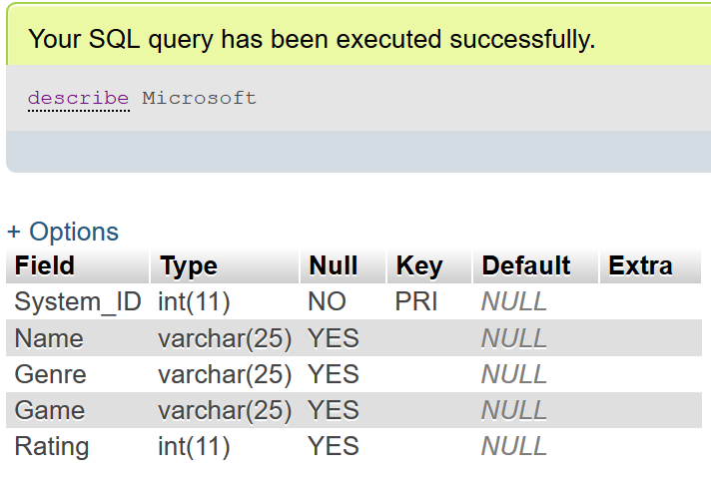  
  
**Insert_Microsoft Stored Procedure**  
DELIMITER $$

CREATE DEFINER=`kyle`@`localhost` PROCEDURE `Insert_Microsoft`(IN `SYSTEM_ID` INT(11), IN `NAME` VARCHAR(25), IN `GENRE` VARCHAR(25), IN `GAME` VARCHAR(25), IN `RATING` INT(11))

NO SQL

INSERT INTO `Microsoft` (`System_ID`, `Name`, `Genre`,`Game`,`Rating`)

VALUES(SYSTEM_ID, NAME, GENRE, GAME, RATING)$$

DELIMITER ;

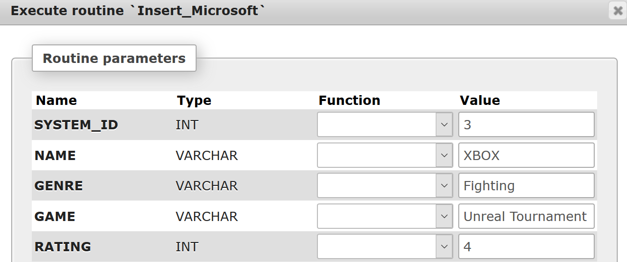  
  
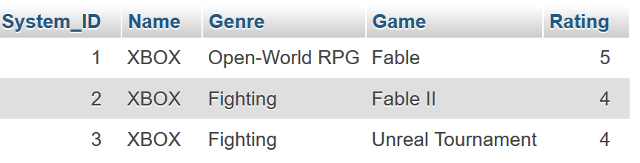  
Result of executing Insert_Microsoft in phpmyadmin   
  
**Update_Microsoft Stored Procedure**   
DELIMITER $$

CREATE DEFINER=`kyle`@`localhost` PROCEDURE `Update_Microsoft`(IN `SYSTEM_ID` INT(11), IN `NAME` VARCHAR(25), IN `GENRE` VARCHAR(25), IN `GAME` VARCHAR(25), IN `RATING` INT(11))

NO SQL

UPDATE `Microsoft`

SET `Name` = NAME, `Genre` = GENRE,`Game` = GAME,

`Rating` = RATING

WHERE `Microsoft`.`System_ID` = SYSTEM_ID$$

DELIMITER ;

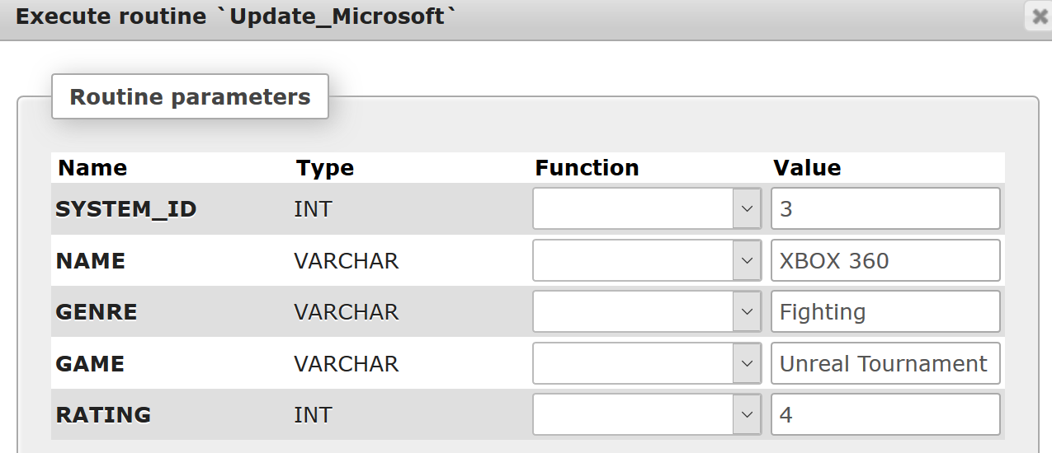  
  
  
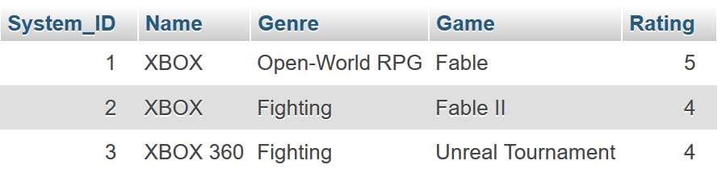  
Result of executing Update_Microsoft in phpmyadmin   
  
**Delete_Microsoft Stored Procedure**  
DELIMITER $$

CREATE DEFINER=`kyle`@`localhost` PROCEDURE `Delete_Microsoft`(IN `SYSTEM_ID` INT(11))

NO SQL

DELETE FROM `Microsoft` WHERE `Microsoft`.`System_ID` = SYSTEM_ID$$

DELIMITER ;

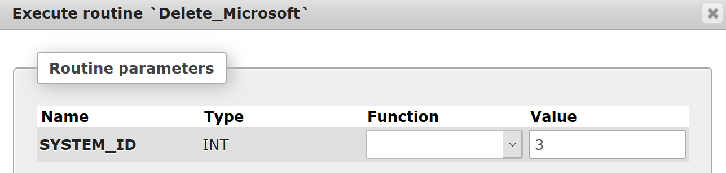  
  
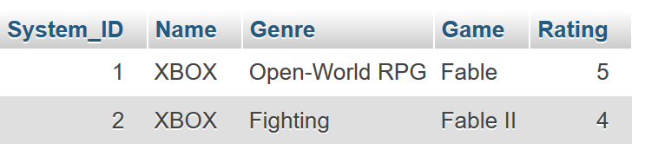  
Result of executing Delete_Microsoft in phpmyadmin